Section A — Concept Application
S 1 SCENARIO
AlphaTech is new to Linux and wants to understand why it is used in enterprise environments.
Question: Explain the history and evolution of Linux, the key differences between Ubuntu, CentOS, Debian, and RHEL, why Linux is preferred over Windows in server environments, and when CLI usage is more appropriate than a GUI for server administration.
1. History and Evolution of Linux
Linux was created by Linus Torvalds in 1991 as a free and open-source operating-system kernel. It was inspired by Unix. Over time, developers around the world contributed to Linux, leading to many Linux distributions such as Ubuntu, Debian, CentOS, and RHEL. Today, Linux is widely used for servers, cloud computing, networking, cybersecurity, and embedded systems.

2. Differences between Ubuntu, CentOS, Debian, and RHEL
Distribution | Main Use | Key Feature
Ubuntu | Desktop, servers, cloud | Easy to use and large community
Debian | Servers and general use | Very stable and community-driven
CentOS | Enterprise servers | Historically compatible with RHEL; CentOS Linux was discontinued and replaced in the ecosystem by CentOS Stream
RHEL | Enterprise servers | Commercial support, certifications, and enterprise tools

3. Why Linux is preferred over Windows for servers
Linux is commonly preferred for many server workloads because it:
- Is open-source and highly customizable.
- Usually requires fewer system resources.
- Provides strong permissions and security controls.
- Is very stable for long-running services.
- Supports powerful automation and scripting.
- Works well with cloud and container technologies.
- Can often be managed without a graphical interface.
4. When CLI is better than GUI
The Command-Line Interface (CLI) is more appropriate when:
- Managing remote servers through SSH.
- Installing or updating packages.
- Configuring services and networking.
- Checking logs and troubleshooting.
- Automating tasks with Bash scripts.
- Managing many servers at once.

S 2 SCENARIO
A junior administrator on AlphaTech's team is learning Linux administration and needs to understand the core file and directory commands.
Question: Explain the purpose of the ls, cd, pwd, mkdir, rm, cp, and mv commands, and describe how each is used in real server management.
Linux provides several basic commands for managing files and directories. The ls command is used to list files and directories. The cd command is used to change the current directory, while pwd displays the current working directory. The mkdir command creates new directories, and rm removes files or directories. The cp command is used to copy files or directories, whereas mv moves or renames them.
1. ls
ls -l /var/log
2. cd
cd /etc
3. pwd
pwd
4. mkdir
mkdir /backup
5. rm
rm old.log
6. cp
cp /etc/ssh/sshd_config /etc/ssh/sshd_config.bak
7. mv
mv website_old website_new

S 3 SCENARIO
AlphaTech wants to install its first Linux server using VirtualBox or VMware.
Question: Explain the steps to install Ubuntu Server or CentOS, and justify why hostname configuration, static IP configuration, SSH setup during installation, and initial system verification are each important before the server goes live.
To install the first Linux server using VirtualBox or VMware, AlphaTech can use Ubuntu Server or CentOS. The basic process is as follows:
1. Create a Virtual Machine
First, install VirtualBox or VMware and create a new virtual machine. Allocate suitable RAM, CPU, and storage, then attach the Ubuntu Server or CentOS ISO file and start the VM.
2. Install Linux
Follow the installation wizard:
- Select language and keyboard.
- Select the disk for installation.
- Create a user and password.
- Select the required software/packages.
- Complete the installation and restart the server.
3. Configure Hostname
A hostname gives the server a unique name on the network.
Example:
hostnamectl set-hostname alphatech-server
Importance: It makes the server easy to identify and manage, especially when AlphaTech has multiple servers.
4. Configure a Static IP
A static IP ensures that the server keeps the same network address.
Example:
IP Address: 192.168.1.50
Gateway: 192.168.1.1
DNS: 8.8.8.8
Importance: Services such as SSH, websites, DNS, and databases need a predictable address so clients can reliably connect to the server.
5. Set Up SSH
SSH allows administrators to remotely access and manage the server.
Example:
sudo apt install openssh-server
sudo systemctl enable --now ssh
For CentOS/RHEL-based systems, the service is commonly named sshd.
Importance: Administrators can securely manage the server remotely without needing a GUI or physical access.
6. Perform Initial System Verification
Before putting the server into production, check that the basic configuration works.
Examples:
hostnamectl
ip addr
systemctl status ssh
ping 8.8.8.8
Also update the system:
sudo apt update && sudo apt upgrade

S 4 SCENARIO
Multiple employees will need access to the AlphaTech Linux server.
Question: Explain how Linux users and groups work, the difference between user and group permissions, how useradd, groupadd, and passwd are used to manage them, and why user isolation matters on a multi-user system.
Linux is a multi-user operating system, so multiple employees can use the same server. Users and groups help administrators control who can access files, directories, and services.
1. Linux Users and Groups
A user represents an individual account on the server. A group is a collection of users who need similar permissions.
Example:
AlphaTech can create a group called developers and add employees such as dev1 and dev2 to it.
2. User Permissions and Group Permissions
Linux mainly uses three types of permissions:
- User (u): Permission given to the owner of the file.
- Group (g): Permission given to members of the file's group.
- Others (o): Permission given to everyone else.
The permissions are:
- r = Read
- w = Write
- x = Execute
Example:
-rwxr-x---
Here, the owner has rwx, the group has r-x, and others have no permission.
3. useradd
The useradd command creates a new user account.
Example:
sudo useradd -m dev1
This creates a user named dev1 with a home directory.
4. groupadd
The groupadd command creates a new group.
Example:
sudo groupadd developers
This creates a group called developers.
A user can then be added to the group:
sudo usermod -aG developers dev1
5. passwd
The passwd command is used to set or change a user's password.
Example:
sudo passwd dev1
The administrator can then enter a password for dev1.
6. Importance of User Isolation
User isolation means that each employee has their own account and controlled access to files and resources.
For example, dev1 should not automatically be able to access another employee's private files.
This is important because it:
- Protects confidential information.
- Prevents unauthorized changes.
- Limits damage if an account is compromised.
- Makes it easier to track who performed an action.
- Provides better security on a multi-user server.
S 5 SCENARIO
A developer on the team asks where system files and user files are stored on the server.
Question: Explain the purpose of the /, /etc, /var, and /home directories, and justify why the Linux directory structure separates files the way it does in server environments.
Linux organizes files and directories in a standard structure. Each directory has a specific purpose, which makes the server easier to manage and troubleshoot.
1. / – Root Directory
The / directory is the top-level directory of the Linux file system. All other directories are located under it.
Example:
ls /
It may show directories such as /etc, /var, /home, /usr, and /tmp.
2. /etc – Configuration Files
The /etc directory contains system and service configuration files.
Example:
ls /etc
Files such as SSH configuration are stored here:
/etc/ssh/sshd_config
3. /var – Variable Data
The /var directory stores data that changes frequently, such as logs, caches, and application data.
Example:
ls /var/log
Server logs are commonly stored in /var/log.
4. /home – User Files
The /home directory contains the personal directories of normal users.
Example:
/home/dev1
/home/dev2
Users can store their documents and personal files inside their own home directory.
Why Linux Separates Directories
Linux separates files according to their purpose so that administrators can easily locate, manage, secure, and back up data. For example, configuration files are kept in /etc, logs in /var, and user files in /home.
This separation is especially useful on servers because it makes security, troubleshooting, backups, and system maintenance easier.
S 6 SCENARIO
AlphaTech needs storage that can grow without downtime as the company scales
Question: Explain what LVM is, its core components (Physical Volume, Volume Group, Logical Volume), its advantages over traditional partitioning, and typical use cases in production servers.
LVM (Logical Volume Management) is a Linux storage management system that allows administrators to create and manage storage more flexibly than traditional disk partitions. It is useful when a server needs to increase storage as the company grows.
1. Physical Volume (PV)
A Physical Volume is a disk or disk partition prepared for use by LVM.
Example:
pvcreate /dev/sdb
Here, /dev/sdb becomes an LVM Physical Volume.
2. Volume Group (VG)
A Volume Group combines one or more Physical Volumes into a single storage pool.
Example:
vgcreate datavg /dev/sdb
The storage from /dev/sdb is now part of the datavg Volume Group.
3. Logical Volume (LV)
A Logical Volume is created from the available space in a Volume Group. It works similar to a normal partition.
Example:
lvcreate -L 10G -n datalv datavg
This creates a 10 GB Logical Volume named datalv.
It can then be formatted and mounted:
mkfs.ext4 /dev/datavg/datalv
mount /dev/datavg/datalv /data
LVM Structure
Physical Disk
↓
Physical Volume (PV)
↓
Volume Group (VG)
↓
Logical Volume (LV)
↓
File System
↓
Mount Point (/data)
Advantages Over Traditional Partitioning
LVM provides more flexibility because administrators can:
- Increase storage capacity more easily.
- Combine multiple disks into one storage pool.
- Resize logical volumes when required.
- Add new physical disks to an existing Volume Group.
- Manage storage without depending entirely on fixed partitions.
Production Server Use Cases
LVM is commonly useful for:
- Database servers
- File servers
- Web servers
- Application servers
- Backup storage
- Servers where storage requirements may increase over time

Section B — Practical Server Administration Tasks
Task 1: Linux Installation, Hostname & Core Commands
- Install Linux (Ubuntu Server or CentOS) on VirtualBox/VMware and set the hostname to alphatech-server
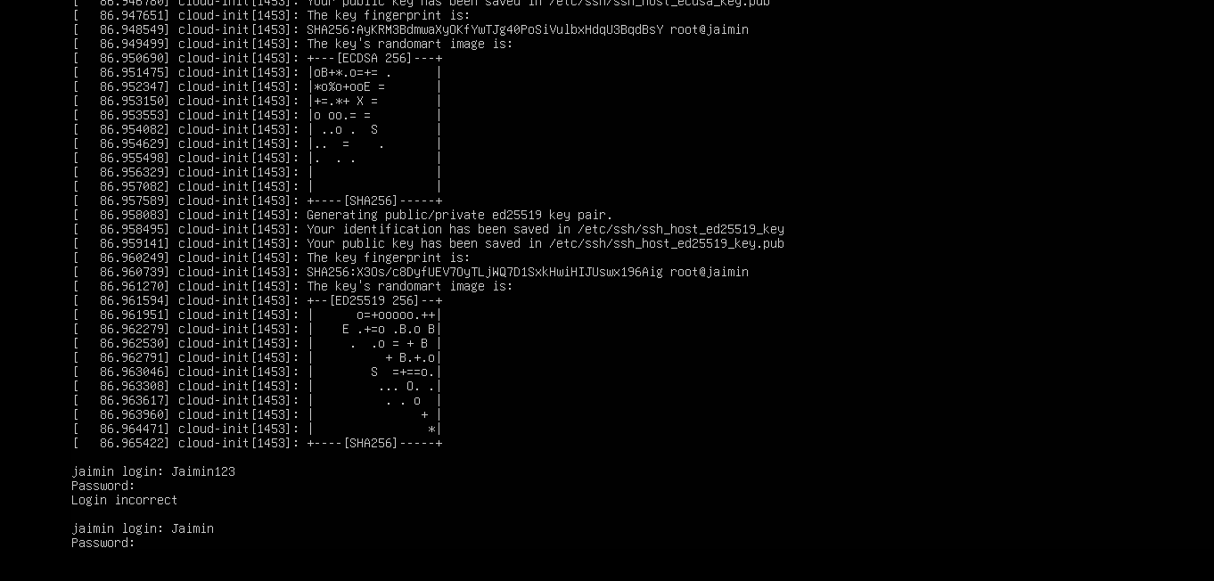

- Configure a static IP address and enable the SSH service
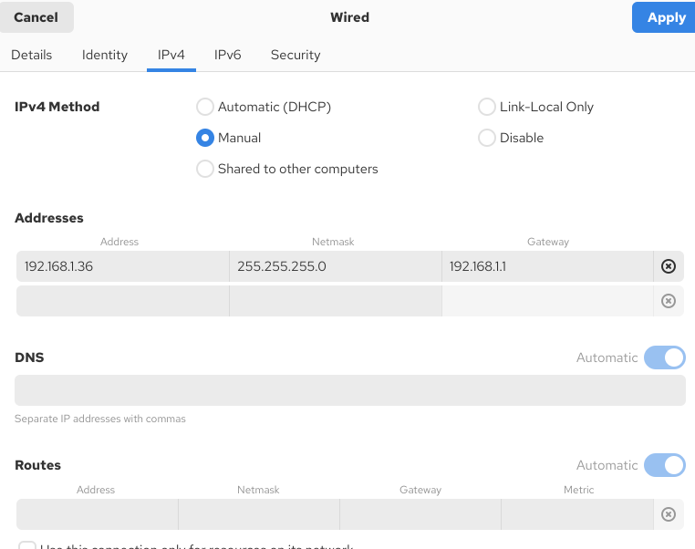
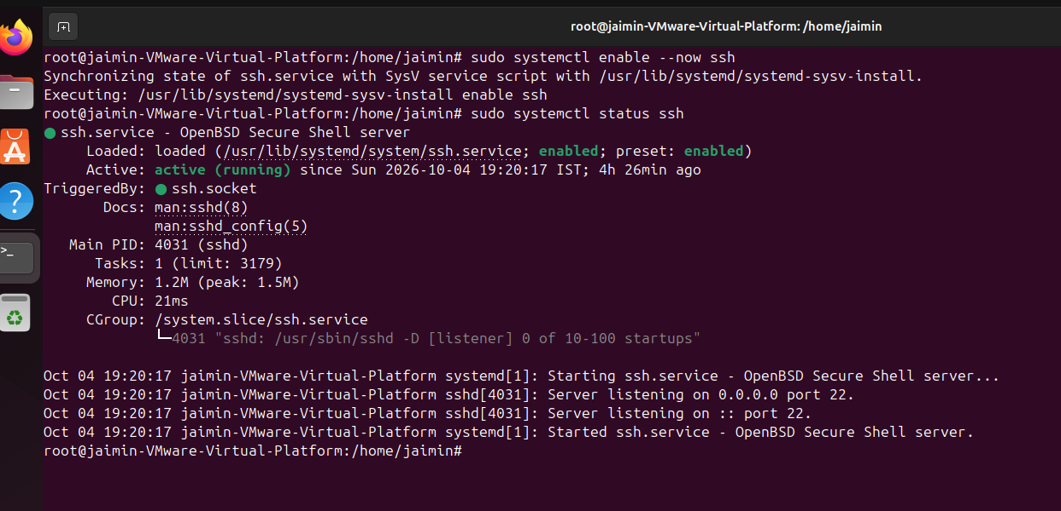
- Verify system connectivity after setup.
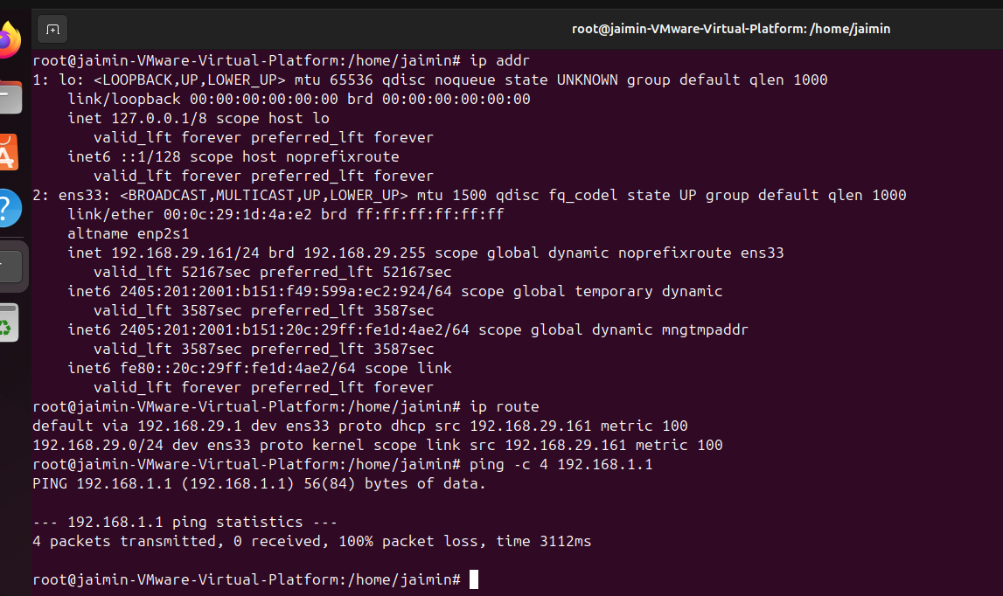
- Use ls, mkdir, cp, mv, and rm to list /etc contents, create /testdir, and copy, move/rename, and delete test files
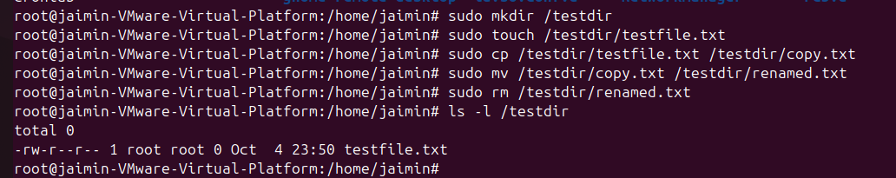
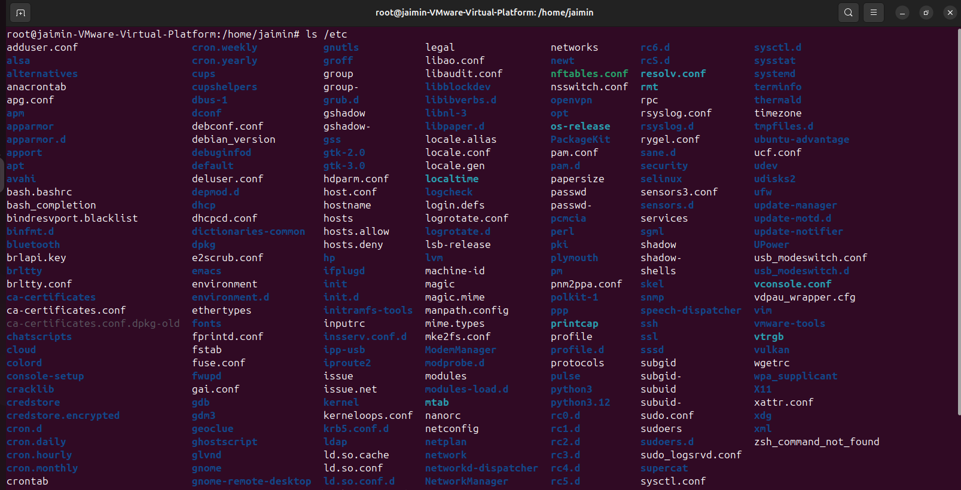
Task 2: User & Group Management
- Create group devteam.
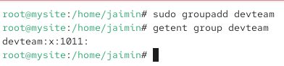
- Create users dev1 and dev2 and set a password for each.
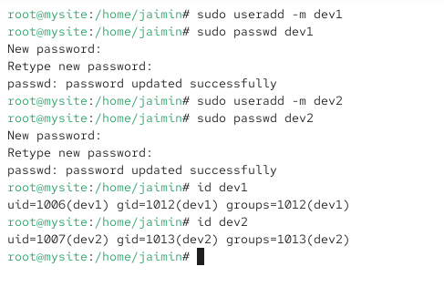
- Add both users to the devteam group.
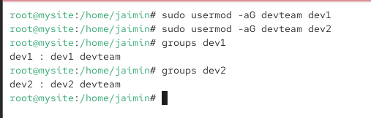
- Verify group membership for both users.
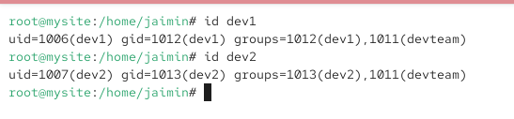
Task 3: File System Permissions & Network Configuration
- Create /project with subdirectories /project/docs and /project/scripts, and set ownership to dev1:devteam.
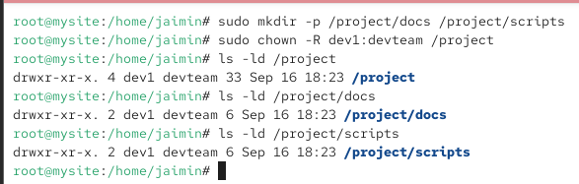

- Set permissions so the owner has full access, the group has read & execute, and others have no access; create and verify one symbolic link and one hard link.
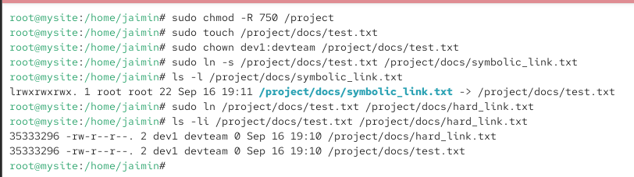
- Configure a static IP, gateway, and DNS, then verify connectivity using ip addr, ip route, and ping google.com.
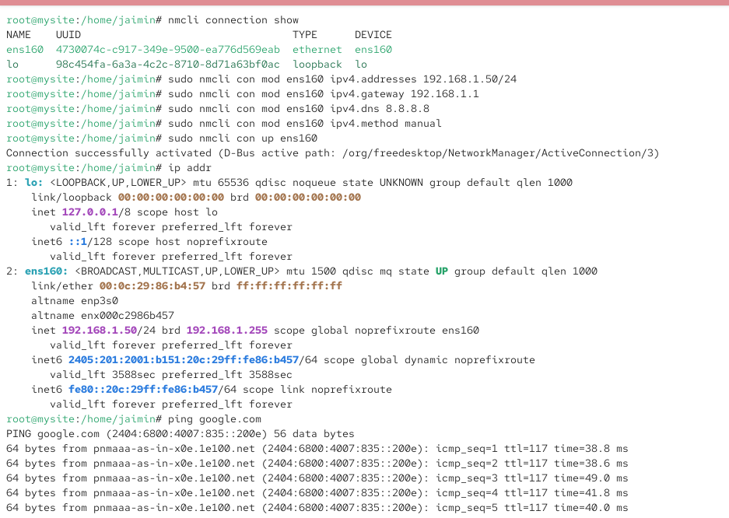
- Confirm the hostname configuration is correct.
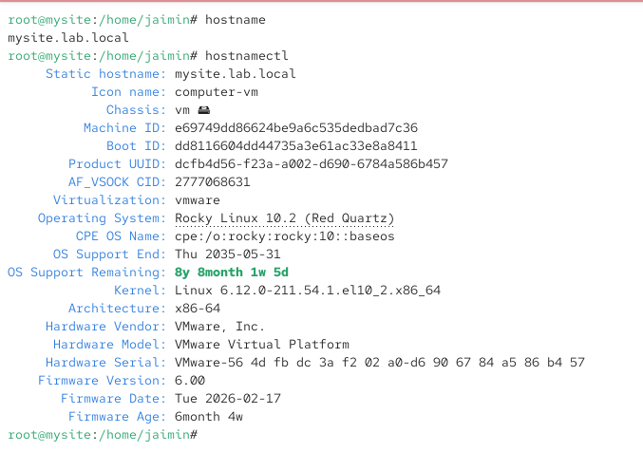
Task 4: LVM Storage Configuration & System Verification
- Create a Physical Volume, Volume Group, and Logical Volume, then format the LV with ext4 or xfs and mount it to /data.
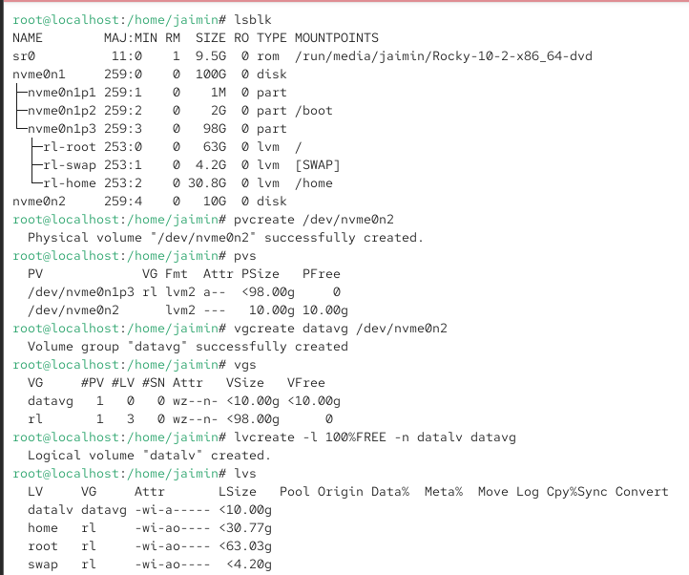
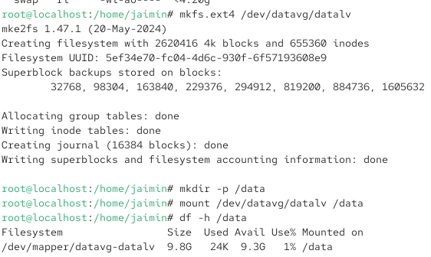

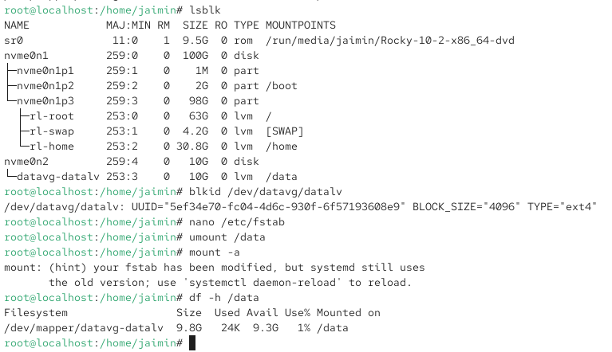

Verify storage usage and extend the logical volume if space is available.
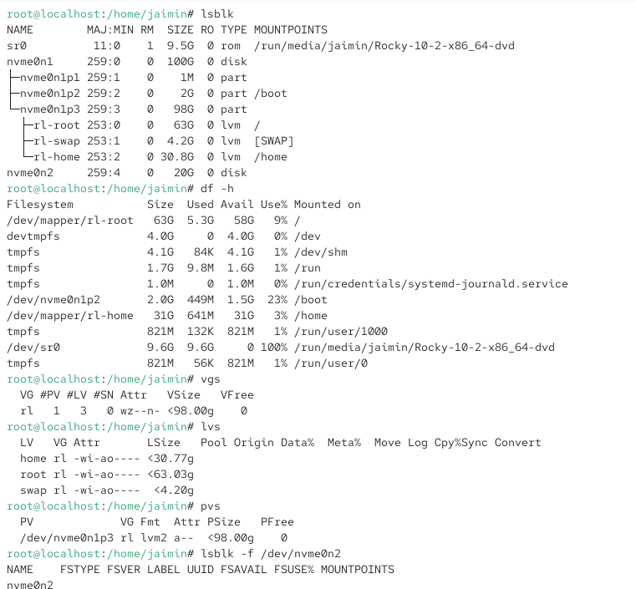
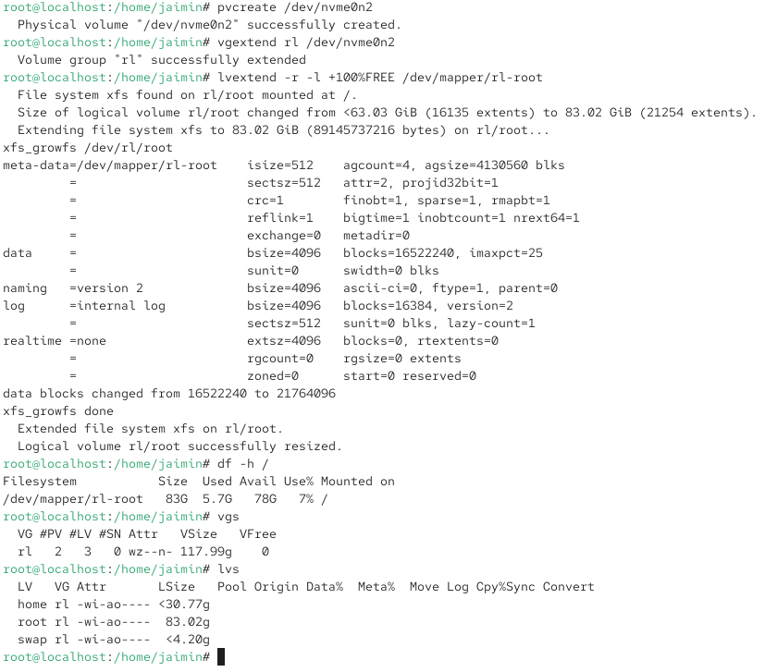
- Verify that users were created correctly, the network is working, SSH is accessible, and storage is mounted.
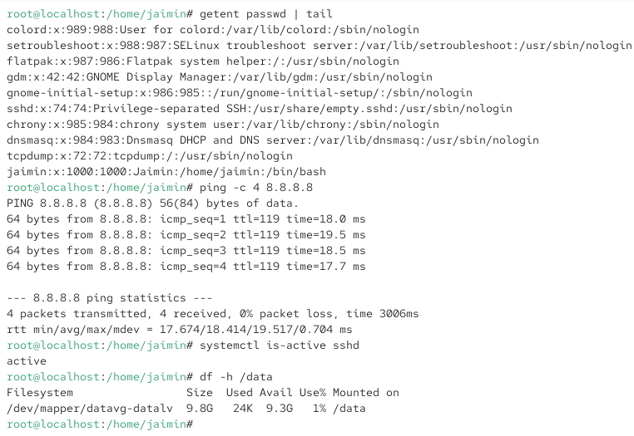
- Confirm that all permissions configured in Task 3 were applied correctly.
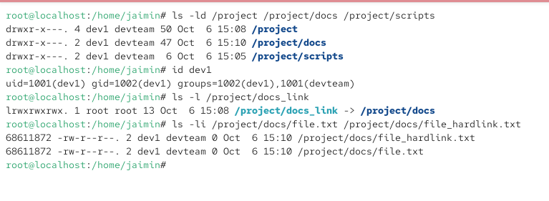

Section C — Mini Capstone Project
Mini Project: AlphaTech Server Recovery & Troubleshooting Objective.
Your project must:
- Diagnose and fix SSH failing to start after reboot: check service status, restart the service, and enable it at boot.
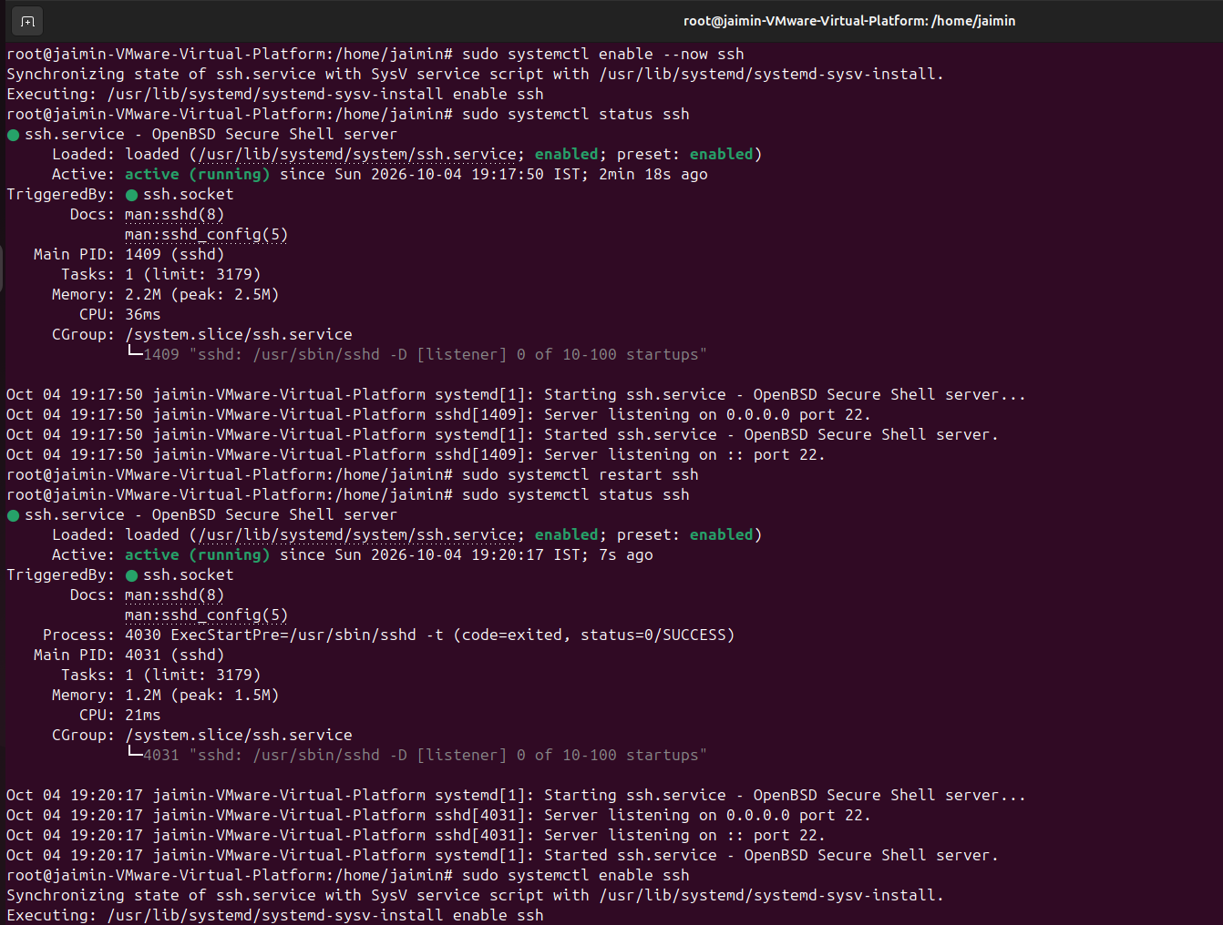
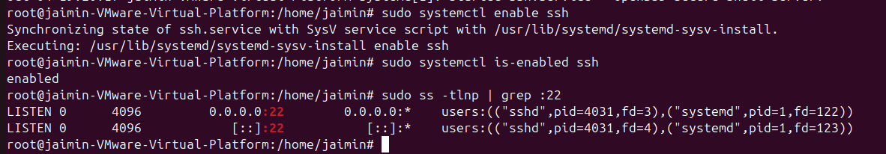
- Resolve a Permission Denied error on /project by checking and correcting ownership and permissions, then validating access
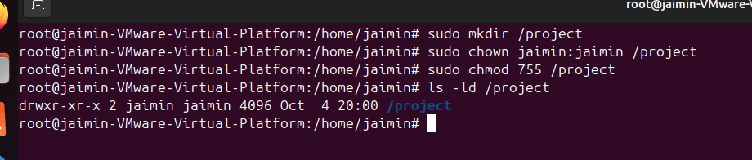
- Resolve a disk that is 100% full by checking usage and using LVM to extend storage without downtime.
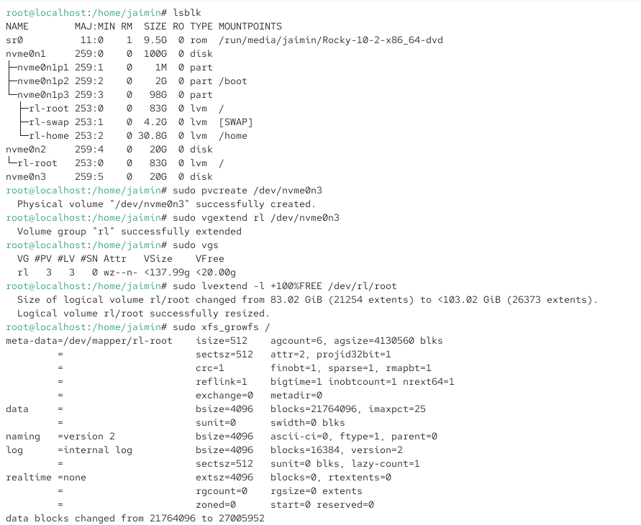
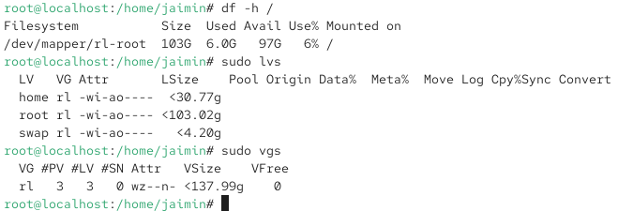
- Diagnose a server that cannot reach the internet by checking IP configuration, DNS settings, gateway, and connectivity.
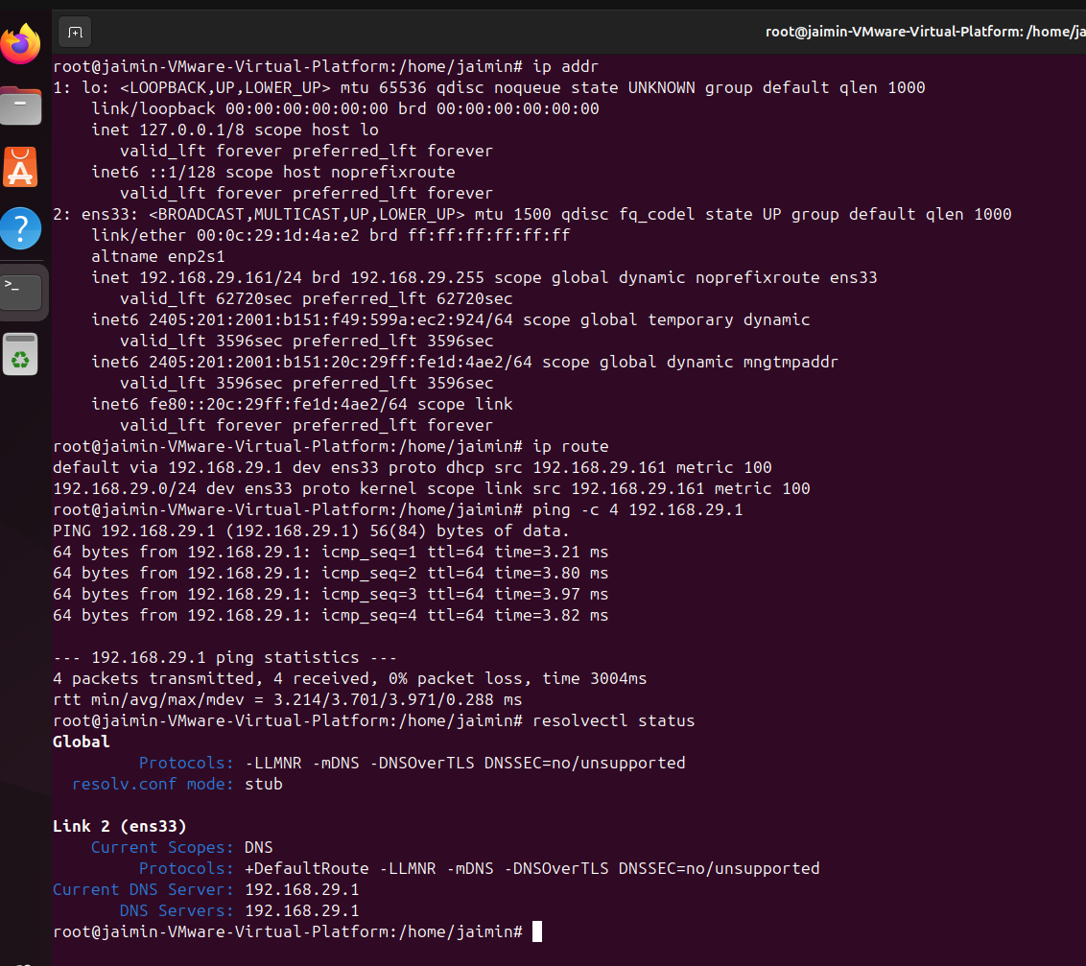
- Resolve new users being unable to log in by verifying user creation, password status, and group membership.
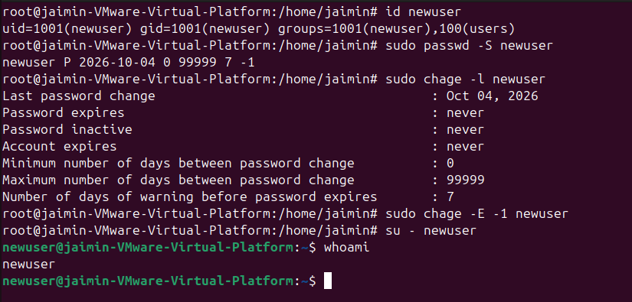

Section D — AI-Augmented Learning
STEP 1 · BUILD WITH AI
- Creates a new user and group, adds the user to the group, and sets a password.
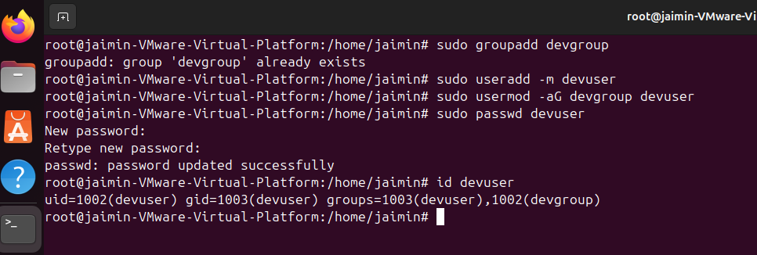
- Creates a project directory structure and applies the owner/group/other permissions used in Task 3.
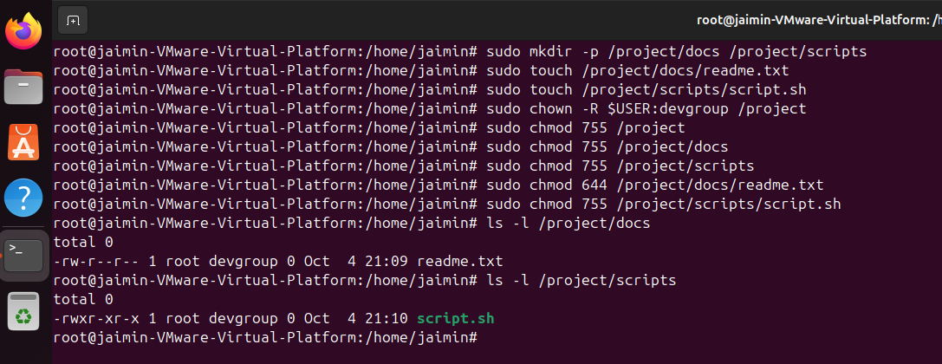
- Checks and reports current disk usage for all mounted volumes.
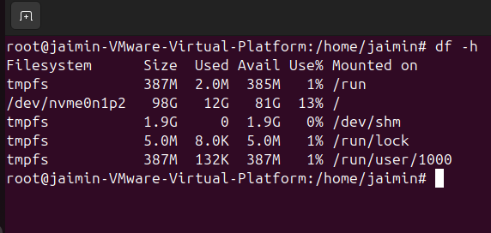
- Prints a summary confirming each step completed successfully
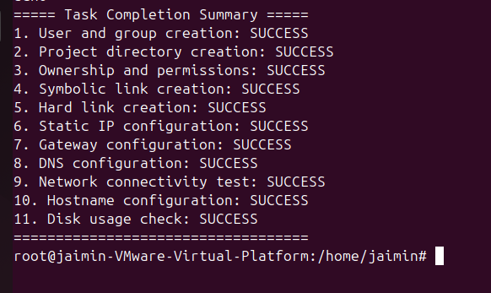

STEP 2 · TEST & DEBUG (WITHOUT AI)
Then, working without AI, test the script on a live server and find at least one bug, limitation, or unsafe assumption in the AI's solution (e.g. missing error handling, no check for existing users, incorrect permission bits, or unquoted variables). Fix it yourself.
